Weekly Photo Contest Rules: 2012-2013

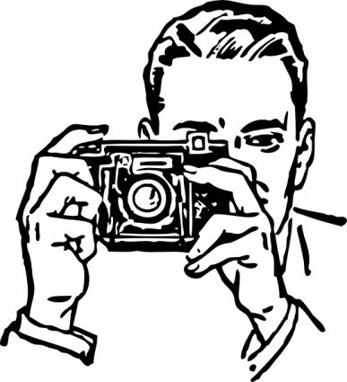
- No entering other classrooms.
- Keep talking to a low volume.
- No running or screaming-remain silent near classrooms.
- No climbing on railings, stairwells, etc.
- Return to classroom at the designated time.
- All students must wear and return a photo badge.
- When using Canon Rebel SLR’s please keep strap on around your neck.

Camera Care

- Do not leave the camera anywhere-keep it around your neck!
- Keep SLR bag at your desk-return to the proper bag (batteries/chargers specific to camera).
- If camera isn’t functioning properly return to classroom.
- After downloading photos please “format” the card-Menu-Tools-Format.
- Don’t touch lens-if lens is dirty ask teacher for lens cloth.
- Leave camera on default settings until you learn functions.
- If you make changes to settings please return to defaults:
  - Lens on AF (autofocus)
  - ISO on auto
  - Dial on “P” for Program
  - White Balance on Auto
  - Picture style on standard
  - Shooting mode on single
  - Exposure compensation (+/-) on “0”

