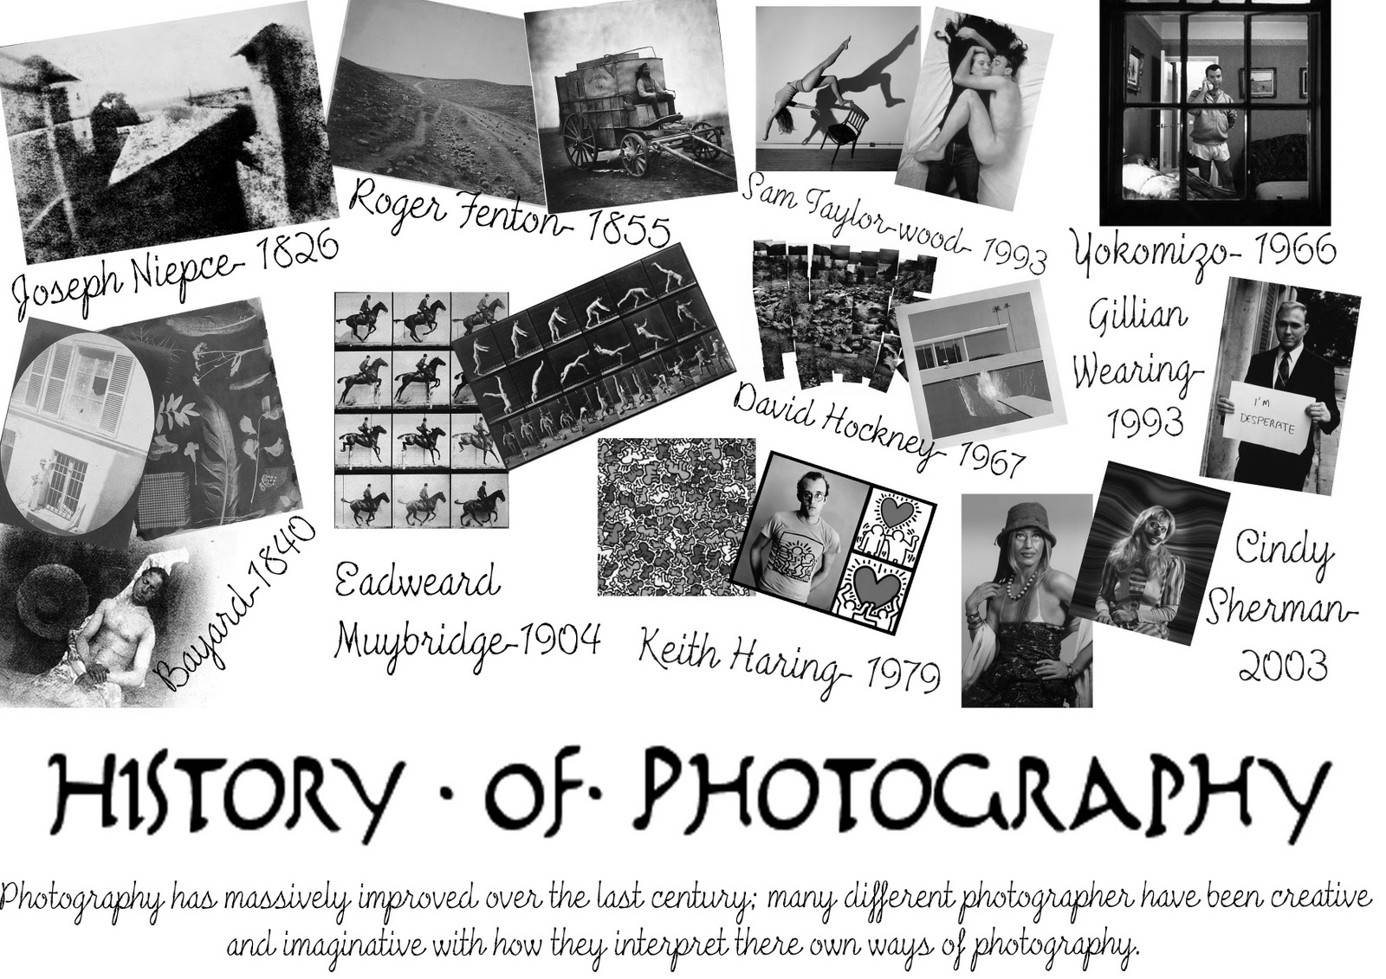
Rubric: Project #1: Photography Timeline
Due: Friday, September 2nd, 2016

Group/Partners
- _______________________
- _______________________
- _______________________

Objective: Students will use Google Slides (or an acceptable alternative app like Prezi) to create a timeline presentation of important events in the history of modern photography (post permanent image era-after 1826).

1. Product: Create timeline with appropriate dates, titles, events, etc. 5 4 3 2 1

2. Events: Feature (with images) a minimum of 20 events on timeline. 5 4 3 2 1

3. Content: Demonstrates understanding of milestones in photography. 5 4 3 2 1

4. Presentation: Presentation is attractive, neat, and shows effort. 5 4 3 2 1

5. Sharing: Successfully uploaded a file to Google Classroom. 5 4 3 2 1

Totals /25 x4= /100

Grade: Comments:

