Rubric: Project #3: Around the World Group Name Per.
Due: Tuesday, March 5, 2013 Score /100

Task: In groups of 2-5 students, use the classroom green screen and images from the Internet to travel the globe: Your group must me represented on each of the world’s seven continents. Make sure you label each final image with the name of the continent (find a creative way to do it-maybe you can even “sneak” group name into each image?

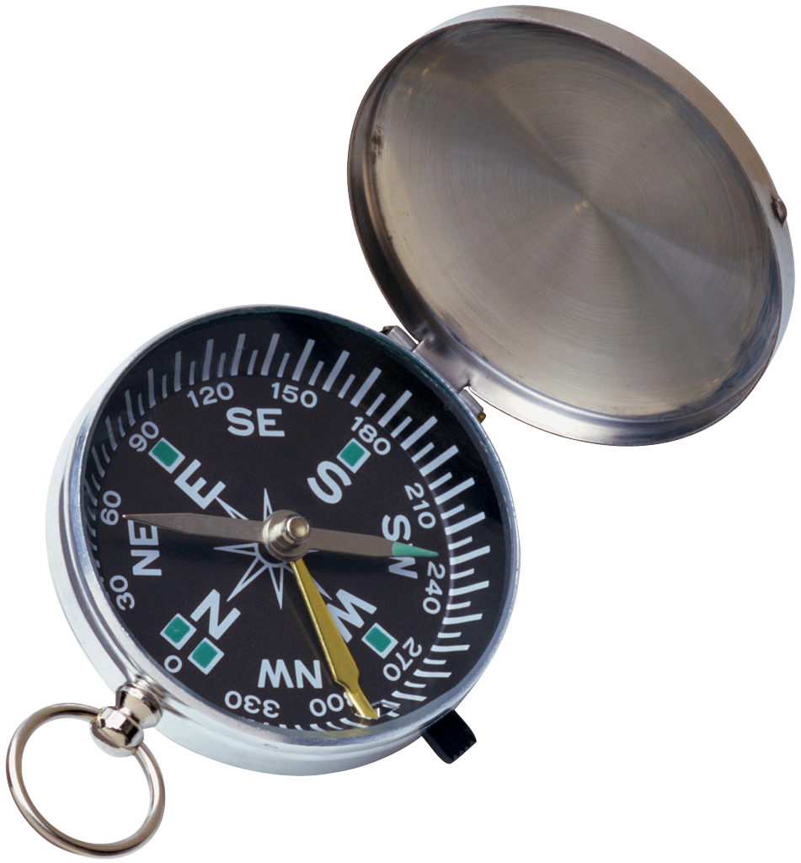
Have fun with this project-be creative-but also be technically correct. There is no excuse for poor lighting or focus in the classroom green-screen environment!

Group Members
- _______________________
- _______________________
- _______________________
- _______________________
- _______________________

1. Tasks: group creatively transported members to
each continent-and labeled each final image. 5 4 3 2 2

2. Photo Quality: photos show good image quality
(Good even lighting, focus, composition, etc.). 5 4 3 2 1

3. Creativity: group came up w/ creative/fun
ways to travel the globe! 5 4 3 2 1

4. Post-production: Ph`hop used to
create attractive authentic-looking images. 5 4 3 2 1

5. Printing: Group created one-page collage of all 5 4 3 2 1
seven images (Word/Photoshop-format, reduce, etc.).

Self-evaluated Totals: /25 x4= /100

Grade: Comments:

