Rubric: Project #6: Aperture Priority/Shallow D.O.F. Name
Due Date: Friday, November 9th, 2012 Period

Aperture priority, often abbreviated Av (for Aperture value) or A on a camera mode dial, is a setting on some cameras that allows the user to choose a specific aperture value while the camera selects a shutter speed to match. The camera will ensure proper exposure. This is different from manual mode, where the user must decide both values, shutter priority where the user picks a shutter speed with the camera selecting the aperture to match, or program mode where the camera selects both.
The main purpose of using aperture-priority mode is to control the depth of field. Aperture priority is useful in landscape photography, where a narrow aperture is necessary if objects in foreground, middle distance, and background are all to be rendered crisply, while shutter speed is often immaterial. It also finds use in portrait photography, where a wide aperture is desired to throw the background out of focus and make it less distracting.

1. Take at least 20 original shots in aperture priority-
Use your cameras largest (smallest #) aperture. 5 4 3 2 1
2. Select/edit (i-Photo) one best/favorite images-label w/
your name and SHALLOW depth of field. 5 4 3 2 1
3. Quality: selected image show good image quality:
(Focus, lighting, resolution, etc). 5 4 3 2 1

4. Composition: selected images show good planning,
composition, (maybe rule of thirds/maybe frame shot) & D.O.F. 5 4 3 2 1

5. Reflection: Written reflection/log of technical
Specs (f-stops/shutter/ISO) and what was learned. 5 4 3 2 1

Self-evaluated Totals: /25 x4= /100

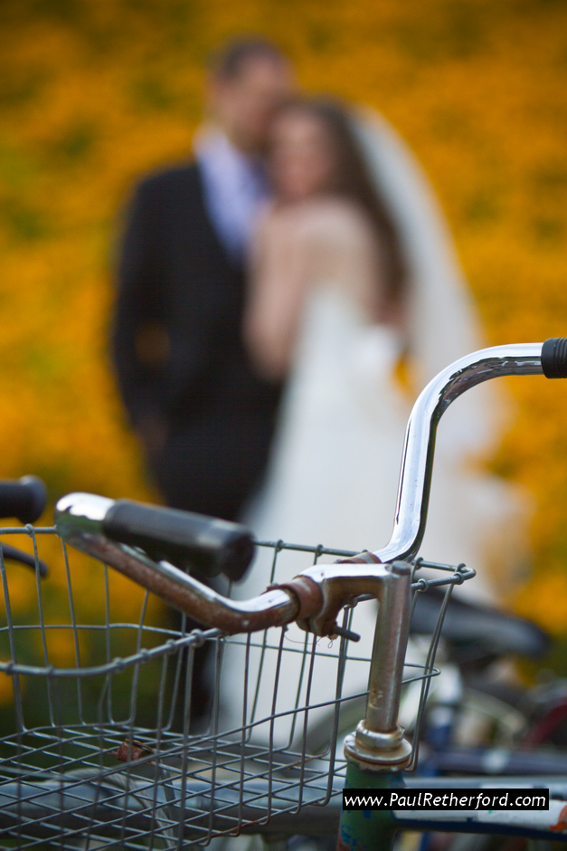
Grade: Comments:
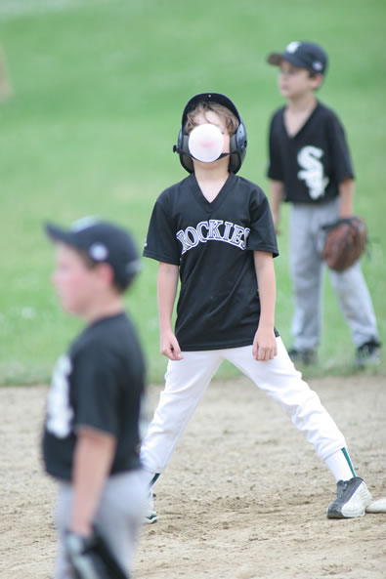
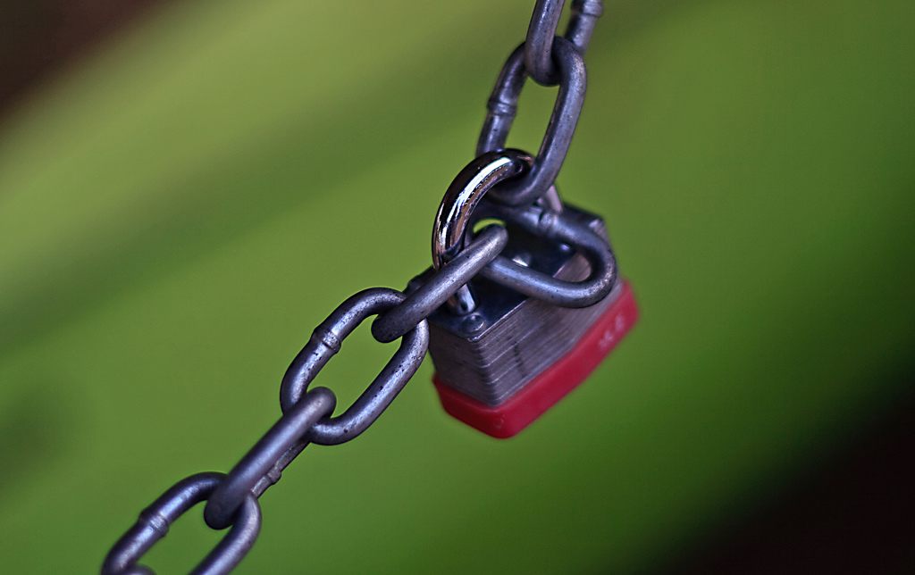



Shallow Depth of Field Near/Far Approach

Tips for Aperture Priority
- Set camera to aperture priority mode (AV on Canon’s, A on Panasonic, etc.).
- SLR’s will give you much better range-and make differences much more noticeable.
- Stop and RECORD each F-stop as you shoot.
- Compose w/ foreground objects (rocks, plants, etc.) to show D.O.F. (near/far) approach.
- Getting closer to subject will emphasize the effect.
- Zooming out (most telephoto) will emphasize the effect-even though your aperture will get smaller.
- Try frame shots (focus on frame and show background blurry).

