Mr. Zeko: News Staff: Digital Camera/Photography Tips

- GET CLOSE! —Make sure your subject fills the entire frame.

- Take action/natural shots: AVOID POSED photos. Get subject doing something!

- Do not rely on telephoto lens to get close -get as close as possible to your subject.

- Don’t shoot into the sun-try to put the sun is behind you!

- Use the flash-ESPECIALLY outdoors-gives subject a crisp look.

- Look for open shade (e.g., the shade of a building). Stay out of direct sunlight!

- When shooting a human subject, do not center the frame on the subject’s face!

- Try to use the rule of thirds!

  - “sweet” spots where lines
cross.

- Take your time to frame your image (think about the background and edges).

- Make sure that your background isn’t distracting-no one wants to see a telephone pole or a branch growing out of their head!

- Take several shots of each subject-try new angles-don’t just repeat the same shot.

- Use auto-focus but allow camera time to focus on the subject (press shutter half way).

- Download images ASAP and identify each shot. Discard all poor quality images.

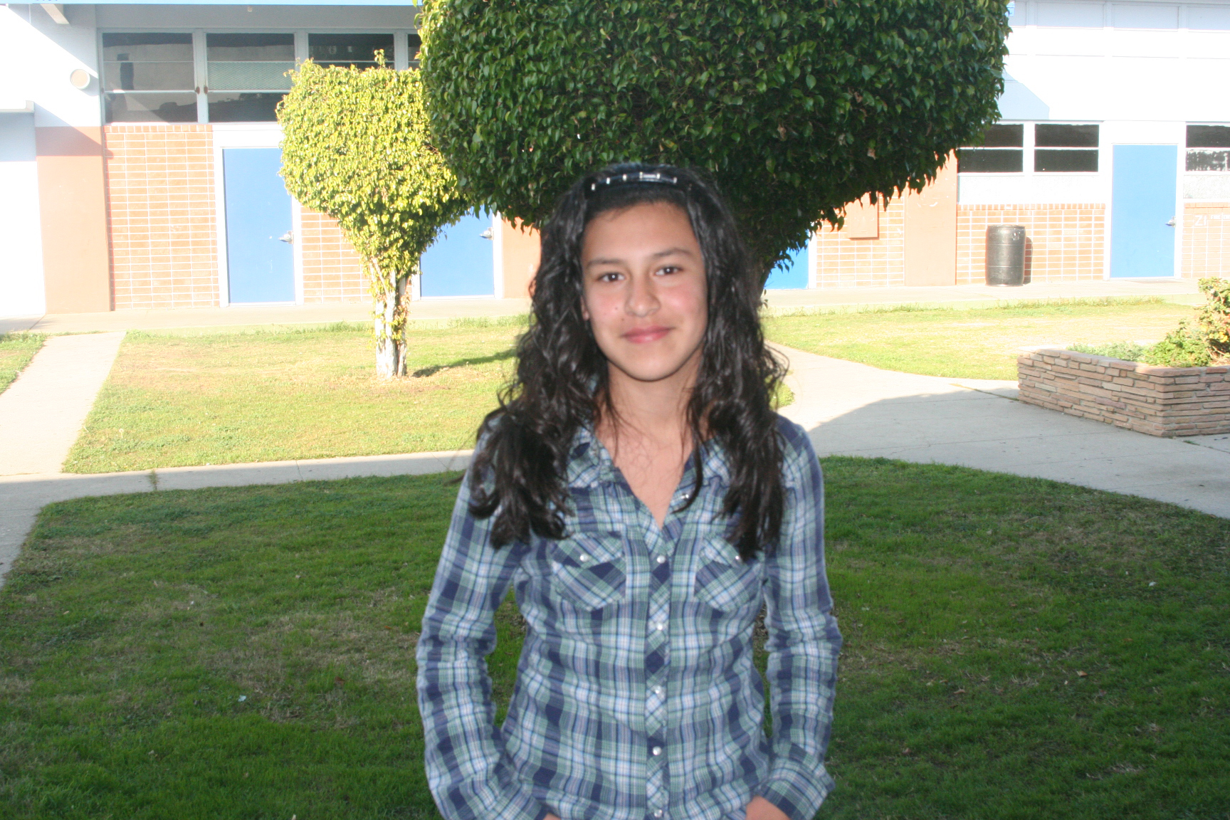
Don’t Do This!!!!!

