25 Photo Composition Tips

Copyright Scott Bourne 2009 - All Rights Reserved
ADDITIONAL PHOTOS by Nicole Young, Rich Legg & Other iStock Contributors
One of the most common problems facing new photographers – and some of us OLD photographers – is finding a great composition. Like pizza, it’s a matter of taste, but there are some fairly standard agreed-upon guidelines for a good composition. I also want to note these are GUIDELINES, not rules. For each of these points you could make an opposite artistic argument. Go there if you must, but if you do, you miss the point of the list. Concentrate on the basics first, then you have earned the right to get fancy and ignore them.
1. Be clear on your subject. What story are you trying to tell with the photo?
2. Draw attention to the subject. This can be done by simply getting closer, by using selective focus, by using color, by lighting just the subject, by framing the subject in a doorway or window, etc.
3. Simplify. Simple is best. Remove anything that doesn’t help you tell the story.
4. When in doubt, leave it out. If there is something in your field of view that is not relevant to the subject or doesn’t somehow support the subject, get rid of it.
5. Check your negative space. Don’t leave too much negative space and when you do have negative space, be sure you use it right. Leave room for the subject in the frame unless you have a specific reason not to.
6. Fill the frame. You can rarely go wrong by filling the frame with the main subject. Many of the best pictures are the simplest ones. You don’t have to add background for the sake of adding background.
7. Check the edges of the frames. Don’t cut off feet or hands of your subject half way. If you want to exclude those appendages, make sure we know you meant to do so. Make a clean crop well above the wrist for instance if you don’t want to include the hands.
8. Check for intruders. Is there something popping into the picture from the side? Is there a tree branch, power line, telephone poll, etc., that creeps into the shot and steals attention from the subject? Re-compose and remove it.
9. Remember POV – Point of View. Shoot up on objects to make them more powerful. Shoot down on subjects to diminish them or make then look less imposing.
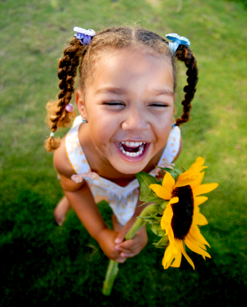
10. Use the rule of thirds. Draw a Tic-Tac-Toe board over your picture in your mind. Position the subject at one of the four intersecting corners in the grid.
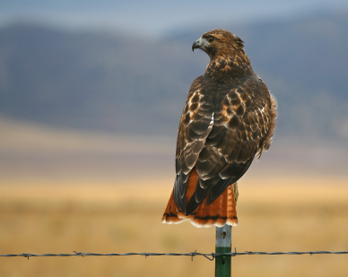
11. When making portraits, always keep the eyes above the center line in the photo.
12. Strive for balance. Look at the composition and determine if there’s something out of place that tilts the viewer’s attention one way or the other.
13. The eye goes to the brightest part of the scene first. So don’t let anything in the photo other than the main subject be brighter than the subject.
14. Add depth by including strong foreground objects in shots where the background is also important.
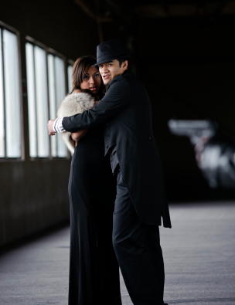
15. Shoot vertically to enhance tall objects or to emphasize height. Shoot horizontally to emphasize width.
16. Use patterns, particularly repeating patterns to make pictures more interesting.
17. Use leading lines to attract the viewer’s eye where you want it to go.
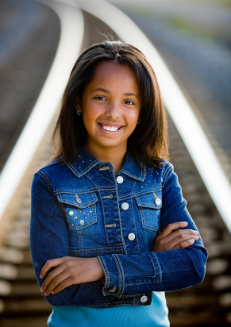
18. Use S-curves or shapes as a more relaxed casual way to lead your eye through the composition. A road or a stream are good examples of this approach.
19. Start by shooting at your subject’s eye level. For example, get down low when making a child or animal’s portrait rather than standing over them and shooting down on them.
20. Make sure there is separation between multiple subjects to avoid unsightly merges.
21. Don’t center everything unless there’s a reason.
22. Don’t let the horizon fall dead center in the picture.
23. Don’t let the horizon cut through the head of any human or animal subject.
24. Don’t let the horizon merge with objects that are important to your image and make sure it is level.
25. Right before you make the photo take a second, look up, look down, look all around and make sure there’s nothing you’re missing.

