10 Photographic Composition Rules
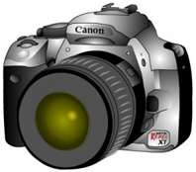
- Rule of Thirds

- Rule of Space

- Rule of Simplicity

- Rule of Odds

- Leading Lines

- Diagonal Lines

- S-Curves

- POV (Point of View)

- Unusual Angles

10. Frame Shots

